# Git Guide by Shane Moran

## 1)Git Clone

You use the “git clone” command to copy or clone an existing repository and move it to your workspace. This will allow you to receive access to the documents within said repository and you can alter these.

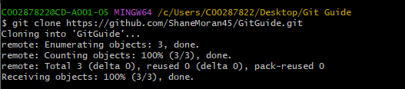

## 2)Git Status

The “git status” command allows the user to see the current state of the working directory. It will display to the user what changed have been made, and what haven’t. I like to use this command pretty frequently, to show me what documents have been altered.

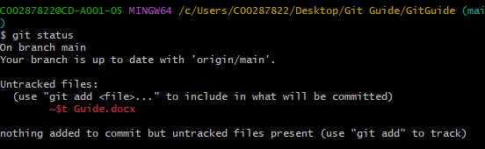

## 3) Git Add

The purpose of the “git add” command is to add your changes to a staging area, this will then allow you to push these changes up to the main document, making them permanent.

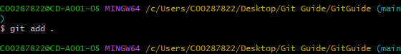

## 4)Git Commit

When you have added all your changes to the staging area, you have to use the “git commit” command to verify these changes on your branch, making them permanent.

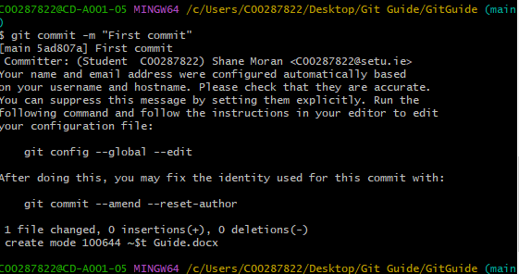

## 5)Git Branch

The purpose of the “git branch” command is to allow the user to create a branch off the main branch, and make changes to this branch without effecting the main branch. When the user has completed all of the changes that they would like to make they can then merge this into the main branch, allowing for progress to be made in a lot safer method.

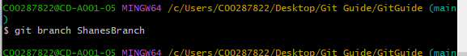

## 6)Git Checkout

After a user has made a branch, they will use the “git checkout “branch name” ” command to swap over to the branch.

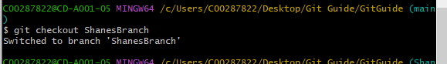

## 7)